Opinion | OP-ED CONTRIBUTOR

Juveniles Don’t Deserve Life Sentences
By GAIL GARINGER | MARCH 14, 2012

Boston
IN the late 1980s, a small but influential group of criminologists predicted a coming wave of violent juvenile crime: “superpredators,” as young as 11, committing crimes in “wolf packs.” Politicians soon responded to those fears, and to concerns about the perceived inadequacies of state juvenile justice systems, by lowering the age at which children could be transferred to adult courts. The concern was that offenders prosecuted as juveniles would have to be released at age 18 or 21.
At the same time, “tough on crime” rhetoric led some states to enact laws making it easier to impose life without parole sentences on adults. The unintended consequence of these laws was that children as young as 13 and 14 who were charged as adults became subject to life without parole sentences.
Nationwide, 79 young adolescents have been sentenced to die in prison — a sentence not imposed on children anywhere else in the world. These children were told that they could never change and that no one cared what became of them. They were denied access to education and rehabilitation programs and left without help or hope.
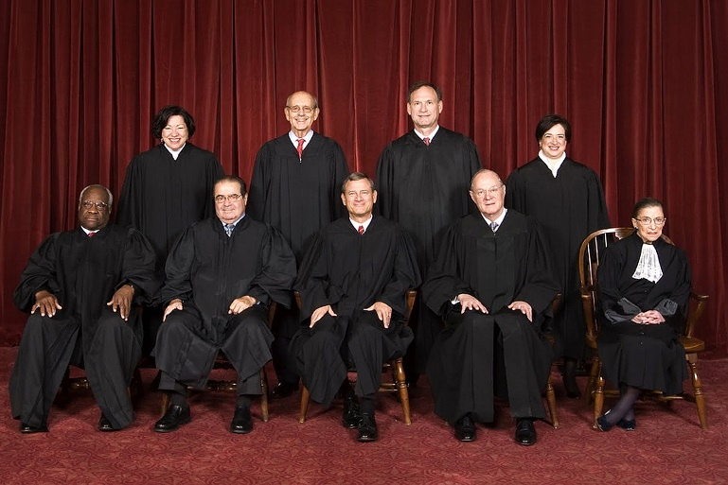

But the prediction of a generation of superpredators never came to pass. Beginning in the mid-1990s, violent juvenile crime declined, and it has continued to decline through the present day. The laws that were passed to deal with them, however, continue to exist. This month, the United States Supreme Court will hear oral arguments in two cases, Jackson v. Hobbs and Miller v. Alabama, which will decide whether children can be sentenced to life without parole after being convicted of homicide.
The court has already struck down the death penalty for juveniles and life without parole for young offenders convicted in nonhomicide cases. The rationale for these earlier decisions is simple and equally applicable to the cases to be heard: Young people are biologically different from adults. Brain imaging studies reveal that the regions of the adolescent brain responsible for controlling thoughts, actions and emotions are not fully developed. They cannot be held to the same standards when they commit terrible wrongs.
Homicide is the worst crime, but in striking down the juvenile death penalty in 2005, the Supreme Court recognized that even in the most serious murder cases, “juvenile offenders cannot with reliability be classified among the worst offenders”: they are less mature, more vulnerable to peer pressure, cannot escape from dangerous environments, and their characters are still in formation. And because they remain unformed, it is impossible to assume that they will always present an unacceptable risk to public safety.
The most disturbing part of the superpredator myth is that it presupposed that certain children were hopelessly defective, perhaps genetically so. Today, few believe that criminal genes are inherited, except in the sense that parental abuse and negative home lives can leave children with little hope and limited choices.

As a former juvenile court judge, I have seen firsthand the enormous capacity of children to change and turn themselves around. The same malleability that makes them vulnerable to peer pressure also makes them promising candidates for rehabilitation.
An overwhelming majority of young offenders grow out of crime. But it is impossible at the time of sentencing for mental health professionals to predict which youngsters will fall within that majority and grow up to be productive, law-abiding citizens and which will fall into the small minority that continue to commit crimes. For this reason, the court has previously recognized that children should not be condemned to die in prison without being given a “meaningful opportunity to obtain release based on demonstrated maturity and rehabilitation.”
The criminologists who promoted the superpredator theory have acknowledged that their prediction never came to pass, repudiated the theory and expressed regret. They have joined several dozen other criminologists in an amicus brief to the court asking it to strike down life without parole sentences for children convicted of murder. I urge the justices to apply the logic and the wisdom of their earlier decisions and affirm that the best time to decide whether someone should spend his entire life in prison is when he has grown to be an adult, not when he is still a child.
Gail Garinger, a juvenile court judge in Massachusetts from 1995 to 2008, is the state’s child advocate, appointed by the governor.

