The Hard News Article
“We don't go into journalism to be popular. It is our job to seek the truth and put constant pressure on our leaders until we get answers.”
--- Helen Thomas, Journalist & White House Correspondent
Driving Question:
How can we tell informative, relevant news stories to an audience while using proper journalistic form and maintaining journalistic neutrality?
Overview:
Students will find a current, interesting issue to investigate and report on in the Hawthorne/El Segundo community. The article will be written from a neutral stand point, and should be merely to inform. Students will be taking on the role of an investigative journalist, and will have to find two credible sources to interview about the topic at hand. Students will also need to refer to other news sources in order to research background information. This issue may or may not be related to the subject of the students’ individual Senior Projects.
Your goal is to write a 300-500 word news article inspired by a current, significant event of your choosing. The article should be designed to look like it would belong in a newspaper or magazine, including all of the relevant parts of an article and using appropriate formatting.
Requirements:
Student | Hard News Article  English 12 :: P2/4 :: Stoll
Your article should have included the following components; any missing components have been bolded
Content: | Form:
- Quotations from at least 2 credible, relevant sources | - Maintains a neutral stance on issue
 | - Inclusion of a relevant photo or visual
- An eye-catching headline | - Strong usage of Inverted Pyramid structure
- A bibliography including 5 sources minimum | - Relevant and complete senses of explanation, amplification, and background information
- Article must be between 300 and 500 words
- Strong Lead Paragraph answering all 5 W’s | - Implementation of the 8 AP Style Rules
Score for CONTENT: __ | Score for FORM: __
NOTES:

Due Dates:
Period 5/7 & 9/11 | Period 2/4 & 10/12
Hard News article due: March 14th | Hard News article due: March 15th
Submitted to TurnItIn.com by 9am | Submitted to TurnItIn.com by 9am
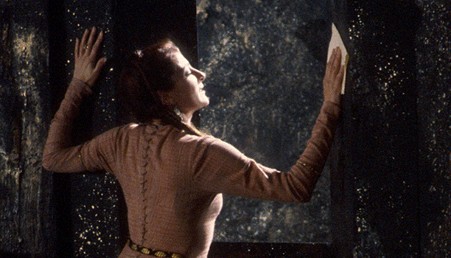
Lady Macbeth Dies Amid Siege on Castle

By: Russell Stoll
Da Vinci Design News Press

DUNSINANE HILL, Scotland (DVDNP) - The newly crowned Queen of Scotland, Lady Macbeth, suddenly died yesterday in the castle at Dunsinane Hill as a rebel army advanced from Birnam Wood.
The queen’s death comes at the height of a revolt being lead against King Macbeth. The revolt is headed by Malcolm, Prince of Cumberland and son of previous ruler of Scotland, King Duncan. Malcolm suspects that Macbeth and his recently deceased wife are responsible for Duncan’s death, and has solicited the help of Macduff, Thane of Fife, and Seward the Elder, from England.
Seyton, manservant of King Macbeth, was the one who reported the queen’s death. “I was with the king when I heard the sound of women screaming,” says Seyton. “I went into the queen’s chamber to find her quite dead.”
King Macbeth could not be reached for a comment at the time of his wife’s death.
“His reaction was rather flat,” reports Seyton. “He mumbled something that she should have died ‘hereafter’, and that then he might have had time to say something. But I thought it was strange because right after he said that, he went off on this poetic tangent for about five minutes.”
Reports show that Lady Macbeth was seeing a doctor for sleepwalking in the weeks leading up to her death. Lady Macbeth’s handmaid told the press that the queen had taken to wandering the castle at nights, doing strange things like washing her hands repeatedly and writing long letters before throwing them away. The doctor was ordered for the queen by her husband, the king.
King Macbeth is still embroiled in the fight for Dunsinane Hill. It would appear that right about the time of Lady Macbeth’s untimely death is when Malcolm’s forces, now estimated at 3000 men, began moving up the hill. Malcolm had instructed his soldiers to pull down limbs from the trees as they marched up the hill, creating the effect that the entire forest was moving, therefore hiding the exact number of his rebel army from the king’s sight.
“Macbeth didn’t like that one bit,” said one of the king’s messengers. “He even threatened to kill me if I was lying! When I said I wasn’t lying, he suggested that I kill him because he was as good as dead. Then he went on and on about some prophecy before he sent out the whole army all at once.”
The messenger wished to be left anonymous, adding, “I personally think the king is losing it. I mean, what kind of husband doesn’t even react to his wife’s death? It’s just sad.”
Reasons for the queen’s sudden death remain unknown, although suicide has been suspected. It is presumed that her death was not connected with the revolt in anyway, as reports of the queen’s death came before the rebel army had reached Dunsinane Hill.
The newly crowned queen was 33 years old.

Answer these prompts to help you structure your article:
What event are you going to write about in your article?
________________________________________________________________________________________________________________________________________________________________________________________________________________________________________________________________________

List the five W’s of your event:
1)_________________________________________________________________2)_________________________________________________________________3)_________________________________________________________________4)_________________________________________________________________5)_________________________________________________________________

Write down three headlines that you could use for your article.
1)_________________________________________________________________2)_________________________________________________________________3)_________________________________________________________________

What are five facts and/or interview sources that you hope to explore/include?
1)_________________________________________________________________2)_________________________________________________________________3)_________________________________________________________________4)_________________________________________________________________5)_________________________________________________________________

