Magazine Project
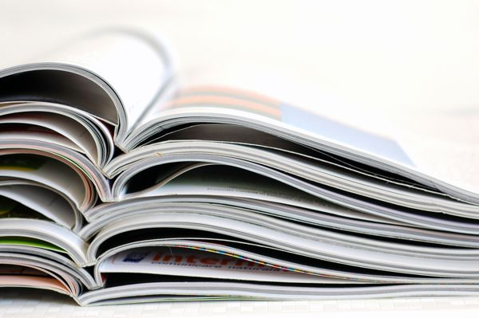
Driving Questions:
What would it look like to design a magazine using content that we collect and create?
How does the form and focus of writing shift based on the intent and audience of a particular article?
Overview:
In groups of 3-4, students will write, edit, and design their own magazines. They will incorporate content from their different classes to create a well rounded collection of articles and art work, and then will publish this collection in a printed booklet.
Deliverables (English 12):
Students will produce the following three writing pieces in English 12 to be included in the final cut of the magazine:
- Hard News Article: Students will find a current, interesting issue to investigate and report on in the Hawthorne/El Segundo community. This article will be written while maintaining “journalistic neutrality”, and will require students to accurately cite two interviewed sources about the issue. This issue may or may not be related to the subject of the students’ individual Senior Projects.
- Feature News Article: Students will include a “features” style article that tells a human interest story. This piece will be a re-edited version of the interview students did for their Podcast Project. Students will need to take the text from their podcast transcript and restructure it so that it follows the principles of a feature news story.

- Satire Article: Students will write a creative satire piece to include in their magazine. The satire article will show that students can employ the four main techniques of humor and satire (exaggeration, incongruity, parody, and reversal) in their own writing. Students will get to write a mock news article criticizing an aspect of society of their choosing.

Resources:
  - Purdue OWL (online) – The Purdue College Online Writer’s Lab is a bank of information of how to write in different formats and for different audiences
  - AP Handbook – The Associated Press Handbook is the reference guide followed by writers that produce journalistic articles for the Associated Press.
  - Adobe: InDesign – InDesign, a software part of the Abode suite, is an accessible, user-friendly program that allows for the creation of books and magazines using drag-and-drop features.
Design Expectations:
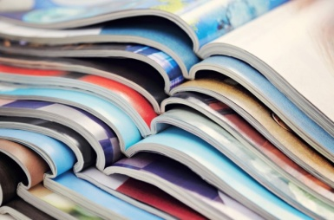
Each group will have the opportunity to create a magazine with a clear vision, a clear focus, and will have to plan the following as a group:
- A Title and slogan for your magazine
- A Cover Page
- A Back Cover
- A Table of Contents
Groups are expected collaborate in order to create a quality magazine that utilizes the articles and art work from all classes in a meaningful, thoughtful manner. A member of each group will have to identify and take responsibility for different aspects of the magazine. Each group member will identify as:
- Editor in Chief: In charge of organizing the layout of the artwork and articles; facilitating the printing of the final magazine product.
- Art Director: In charge of scanning, cropping, and planning any physical artwork that will go in the magazine; in charge of cover art.
- Copy Editor: In charge of organizing the progression of the articles; editing the text of the articles and spell checking/grammar checking the articles for errors.
Dates (subject to change):
Period 5/7 & 9/11 | Period 2/4 & 6/8
Hard News article due: March 13th | Hard News article due: March 13th
Feature News article due: March 18th | Feature News article due: March 19th
Satire article due: March 23rd | Satire article due: March 24th
Magazine Due: March 27th | Magazine Due: March 27th

This magazine will be shown at exhibition and will be the last project of your time at Da Vinci – so make it awesome! Good Luck!

