Magazine Project:
The Satire News Article
OVERVIEW:
For their final article, students will be creating a satirical news article about a fictional event. The purpose of this article should be to both make an audience laugh, but to also make the audience recognize and think about a problem in society.
The satire article will show that students can employ the four main techniques of humor and satire (exaggeration, incongruity, parody, and reversal) in their own writing. Students will get to write a mock news article criticizing an aspect of society of their choosing – however, students should keep in mind that many people will be reading these articles, and they should make every effort not to offend somebody who might read this. (In other words, if this article is not something you would read to your grandma, you probably shouldn’t write about that topic.)
DATES:
Period 5/7 & 9/11 | Period 2/4 & 6/8
Hard News article due: March 13th | Hard News article due: March 13th
Feature News article due: March 18th | Feature News article due: March 19th
Satire article due: March 23rd | Satire article due: March 24th
Magazine Due: March 27th | Magazine Due: March 27th

RUBRIC:
Student | Satire News Article  English 12 :: P2/4 :: Stoll
Your article should have included the following components; any missing components have been bolded
Content: | Form:
- Quotations from at least 2 credible, relevant and fictional sources | - Has a balance of quotations and narration  - Article must be between 200 and 400 words
- An eye-catching headline | - Strong usage of Inverted Pyramid structure
- A clear topic of criticism that is the focus of the article | - Prominent usage of either Exaggeration, Incongruity, and/or Reversal
- Strong Lead Paragraph answering all 5 W’s | - Implementation of the 8 AP Style Rules
Score for CONTENT: __ | Score for FORM: __
NOTES:

Scientists Discover Eating Serves Function Other Than Easing Anxiety
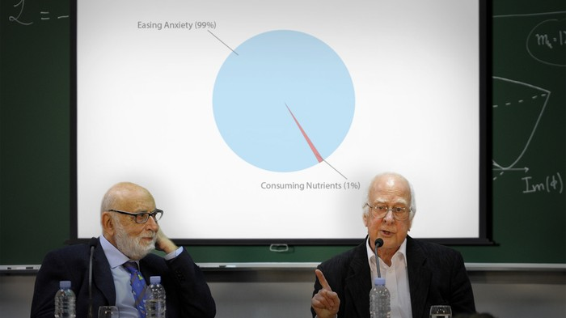
PROVIDENCE, RI—Shedding new light on the biological underpinnings behind the behavior, scientists at Brown University announced Tuesday that eating appears to serve a number of key functions besides relieving anxiety.
“While a considerable portion of food is indeed ingested in order to distract an individual from feelings of panic and insecurity, our research shows that eating actually confers several benefits beyond temporarily holding despair at bay,” said Dr. Sandra Lutkin, who explained that consuming food has been found to provide vital nutrients to the human body and in many cases replenish it with energy, suggesting that its primary purpose may not be as a coping mechanism at all.
“In fact, we observed dozens of subjects and discovered that only a portion of the items they ingested were intended to assuage their apprehension about their job, relationship, or body image. However, much more research must be conducted to learn more about these little-known, non-stress-relieving purposes of eating.”
Although she cautioned the findings were tentative, Lutkin posited that there might be additional methods of eating besides frantically devouring a meal directly over a trash can or sink.
http://www.theonion.com/articles/scientists-discover-eating-serves-function-other-t,38230/
Apple Fans Demand Other Products They Can Feel Directly Against Skin At All Times
SAN FRANCISCO—Following Monday’s unveiling of the highly anticipated Apple Watch, fans of Apple across the nation reportedly called on the company to manufacture more products that they can feel pressed against their skin at all times.
“The watch is a good start, but I need as many devices as possible to be directly in contact with my flesh, like lightweight tablets I can strap to my legs or some kind of Apple chestplate I can wear under my shirt,” said 28-year-old Robert Klinman, echoing the sentiments of millions of Americans who said that any portion of their skin not in contact with an Apple product felt raw and exposed.
“Maybe some kind of flexible Apple scarf, or even a full-body LCD sheet I could wrap my body in over and over, and that I’d never have to take off to sync up to my laptop. I mean, can you imagine anything more comforting than the warmth of your Apple pajamas as they gently charge through the night?”
At press time, Apple consumers confirmed they would do their best with existing technology by wearing an Apple Watch and simply leaning their cheek against an iPad when they got lonely.
http://www.theonion.com/articles/apple-fans-demand-other-products-they-can-feel-dir,38174/

